GAME PROJECT

Programming Fundamentals (Semester 1)

Project Title:
JET FIGHTER: ROCKY ROAD

Submitted To:
Mr. Waseem
Submitted By:
Muhammad Abdullah Rashid
Registration Number:
2025-CS-449
Department:
Department of Computer Science
UET, Lahore
Date:
6 January 2026

1. Introduction

1.1 Project Short Description & Story
Story:
You are the ace pilot of the 'Sky Vanguard' squadron...
Description:
Jet Fighter: Rocky Road is a vertical shooter game developed in C++ without using any external graphics libraries. The player controls a fighter jet navigating through a dangerous asteroid field while dodging enemy missiles.

1.2 Goal of the Game
The primary objective is to survive as long as possible and achieve the highest score.
- Navigate to the top to advance levels
- Avoid collisions
- Destroy enemies and rocks
- Game ends when lives reach zero

2. Technical Implementation

2.1 Data Structures Used
• 2D Character Array (40x60) for map handling
• Parallel Arrays for enemies

2.2 Characters Description
Player: ASCII Jet
Enemy: Missile
Obstacles: Rocks blocking path

2.3 Rules & Interactions
1. Arrow keys for movement
2. Space to fire
3. Collisions reduce lives
4. Difficulty increases with levels

3. Game Screenshots
Figure 1: Start Screen
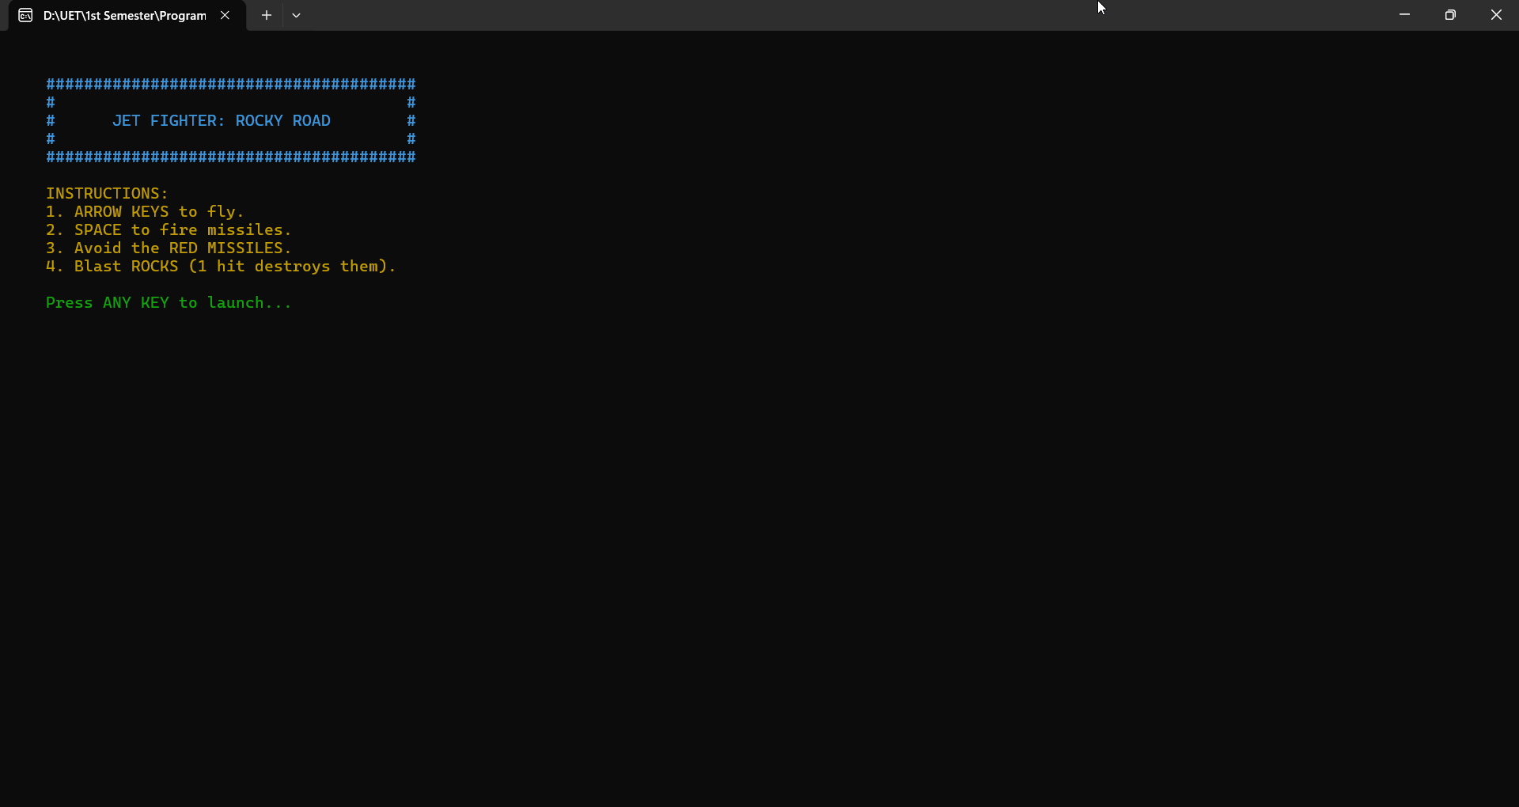
Figure 2: Gameplay
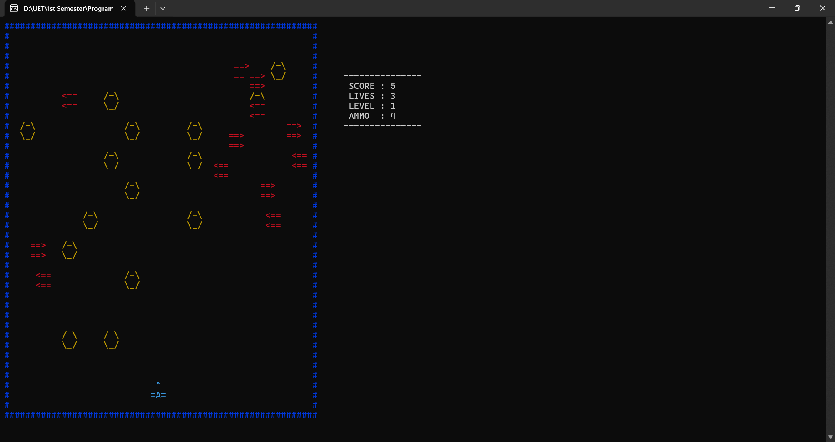
Figure 3: Game Over
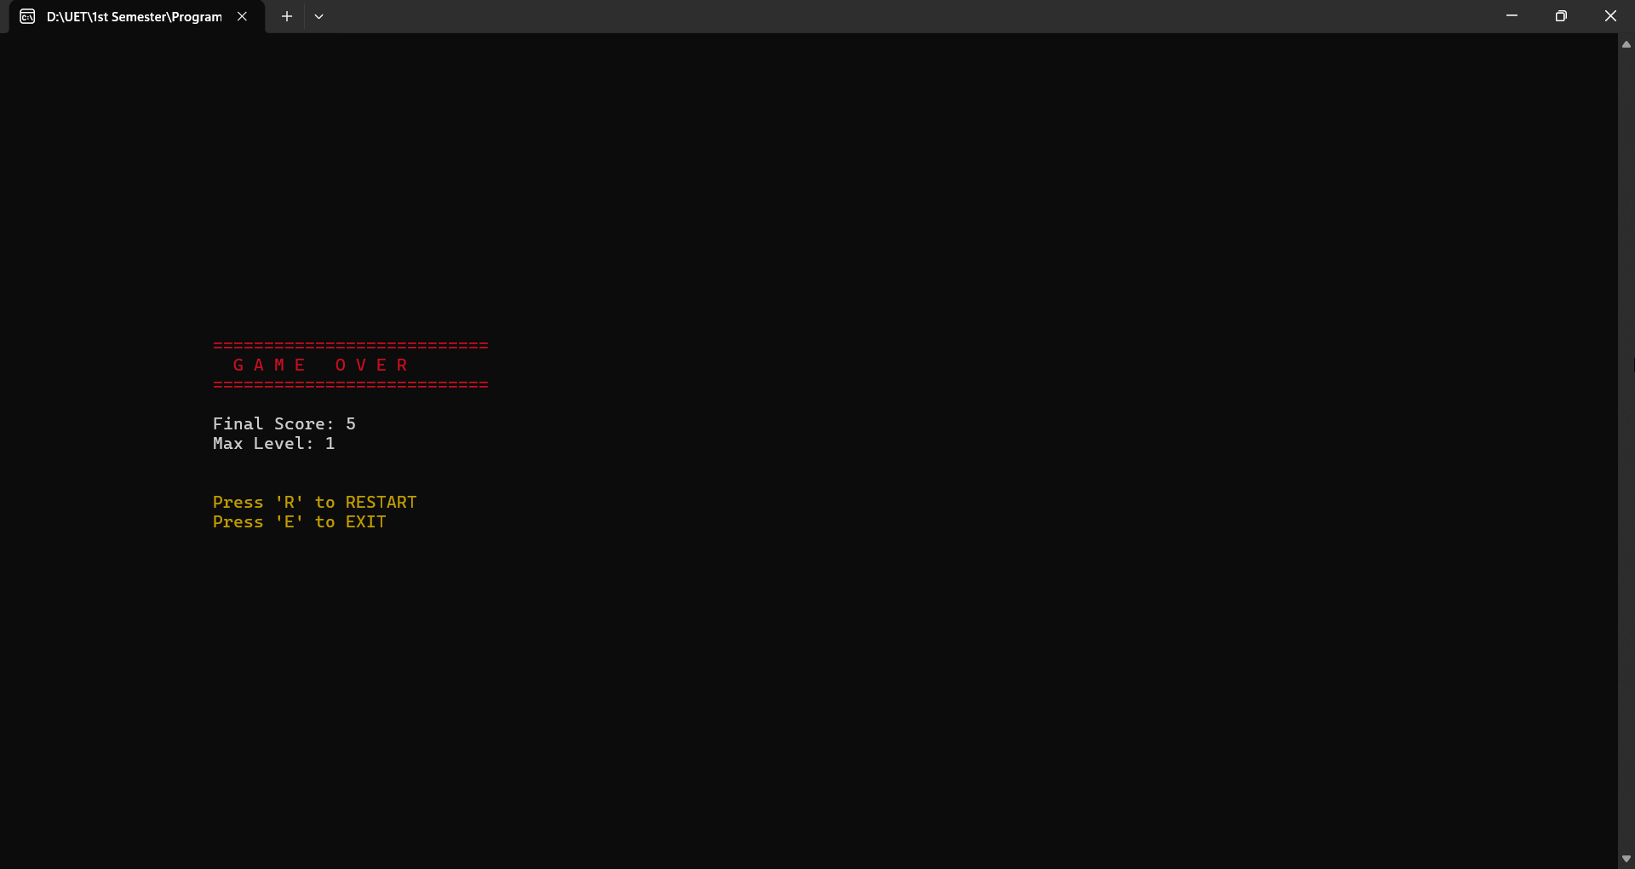

4. Source Code

4.1 Function Prototypes
ShowConsoleCursor()
SetColor()
movePlayer()
moveEnemies()
destroyRock()
saveHighScore()

4.2 Full C++ Code

#include <iostream>
#include <windows.h> // REQUIRED for: gotoxy, SetColor, Sleep (Console Control)
#include <fstream> // REQUIRED for: File Handling (writing to score.txt)
#include <ctime> // REQUIRED for: time(0) to seed random numbers
#include <conio.h> // REQUIRED for: _getch() (Reading key press without Enter)

using namespace std;

// --- GLOBAL CONSTANTS ---
// These control the fundamental size of the game world.
// Using constants makes the code safer and easier to modify later.
const int ROWS = 40;
const int COLS = 60;
const int ENEMY_COUNT = 12; // Total number of missiles patrolling the screen

// --- COLORS ---
// Mapping readable names to Windows Console integer codes for easier usage.
#define BLUE 1
#define GREEN 2
#define CYAN 3
#define RED 4
#define MAGENTA 5
#define YELLOW 6
#define WHITE 7
#define GREY 8

// --- FUNCTION PROTOTYPES ---
// We declare these at the top so the 'main' function knows they exist.
// This allows us to organize the code by putting messy function logic at the bottom.
void ShowConsoleCursor(bool showFlag);
void SetColor(int color);
void gotoxy(int x, int y);
void printStartScreen();
void printMaze(char map[ROWS][COLS]);
void printPlayer(int x, int y);
void erasePlayer(int x, int y);
void movePlayer(int &pX, int &pY, char map[ROWS][COLS]);
void printEnemy(int x, int y, bool right);
void eraseEnemy(int x, int y, char map[ROWS][COLS]);
void moveEnemies(int enemyX[], int enemyY[], bool enemyDir[], char map[ROWS][COLS]);
void generateBullet(int pX, int pY, int &bX, int &bY, bool &isFired, int &ammo);
void moveBullet(int &bX, int &bY, bool &isFired, int enemyX[], int enemyY[], int &score, char map[ROWS][COLS]);
void destroyRock(int bX, int bY, char map[ROWS][COLS]);
void printGUI();
void updateScore(int score, int lives, int level, int ammo);
void saveHighScore(int score);
void resetLevel(char map[ROWS][COLS], int level);

// --- MAIN FUNCTION (Entry Point) ---
int main() {
// 1. WINDOW SETUP
// Forces the window to be 100 columns wide and 50 lines tall.
// This prevents the map from "scattering" on small screens.
system("mode con: cols=100 lines=50");

// 2. RANDOMIZATION SEED
// time(0) returns current time. Used as a seed so every game run is unique.
srand(time(0));

// 3. CONSOLE SETTINGS
// Hides the blinking underscore cursor to prevent screen flickering/visual noise.
ShowConsoleCursor(false);

bool isRunning = true; // Variable to keep the whole game application running
bool firstRun = true; // Variable to ensure Start Screen only shows on launch

// --- OUTER LOOP: Handles Game Sessions (Replayability) ---
while(isRunning) {

// 4. MAP INITIALIZATION (2D Array)
// Creating the grid in memory before drawing it.
char map[ROWS][COLS];
for(int i=0; i<ROWS; i++) {
for(int j=0; j<COLS; j++) {
// If we are at the edges (Row 0, Col 0, Last Row, Last Col)...
if (i==0 || i==ROWS-1 || j==0 || j==COLS-1)
map[i][j] = '#'; // ...Place a wall border
else
map[i][j] = ' '; // ...Otherwise place empty air
}
}

// 5. GAME VARIABLES
int pX = 28; // Player Start X (Horizontal Center)
int pY = 36; // Player Start Y (Bottom of map)
int lives = 3;
int score = 0;
int level = 1;
int ammo = 5;

// 6. ENEMY SETUP (Parallel Arrays)
// We use 3 arrays linked by index 'i'.
// enemyX[0] belongs to the same enemy as enemyY[0] and enemyDir[0].
int enemyX[ENEMY_COUNT] = { 5, 50, 15, 40, 10, 35, 20, 45, 8, 32, 4, 25 };
int enemyY[ENEMY_COUNT] = { 4, 7, 10, 13, 16, 19, 22, 25, 5, 8, 11, 14 };
bool enemyDir[ENEMY_COUNT] = { true, false, true, false, true, false, true, false, true, false, true, false };

// Bullet Variables
int bX = -1; // -1 means bullet doesn't exist yet
int bY = -1;
bool isFired = false;

// Enemy Speed Timer
// Used to make enemies slower than the main game loop
int enemyTimer = 0;

// Show Instructions (Only once per program run)
if (firstRun) {
printStartScreen();
firstRun = false;
}

// 7. INITIAL DRAW
system("cls"); // Clear the screen completely
resetLevel(map, level); // Generate rocks based on Level 1 density
printMaze(map); // Draw walls and rocks
printPlayer(pX, pY); // Draw player
printGUI(); // Draw Scoreboard borders

// --- INNER LOOP: Active Gameplay ---
// Runs continuously as long as player is alive.
// Each loop iteration is one "Frame" of the game.
while (lives > 0) {

// A. Update Score Numbers (Fastest, every frame)
updateScore(score, lives, level, ammo);

// B. Player Movement
// Checks keyboard input and updates pX/pY if valid
movePlayer(pX, pY, map);

// C. Shooting Input
// GetAsyncKeyState checks if Space is held down without pausing the game
if (GetAsyncKeyState(VK_SPACE) && !isFired) {
if (ammo > 0) {
generateBullet(pX, pY, bX, bY, isFired, ammo);
}
}

// D. Enemy Speed Control (The "Tick" System)
int speedThreshold;

// Determine how often enemies move based on Level
if (level <= 3) speedThreshold = 3; // Slow (Move every 4th frame)
else if (level <= 6) speedThreshold = 2; // Medium (Move every 3rd frame)
else speedThreshold = 1; // Fast (Move every 2nd frame)

// Only update enemy position if enough "frames" have passed
if (enemyTimer >= speedThreshold) {
moveEnemies(enemyX, enemyY, enemyDir, map);
enemyTimer = 0; // Reset counter
}
enemyTimer++; // Count this frame

// E. Bullet Physics
// Bullets always move fast (every frame)
moveBullet(bX, bY, isFired, enemyX, enemyY, score, map);

// F. Collision Detection
for(int i = 0; i < ENEMY_COUNT; i++) {
// Check if Player is overlapping with any Enemy
// abs() gets absolute distance. <3 X means horizontal overlap, <2 Y means vertical.
if (abs(pX - enemyX[i]) < 3 && abs(pY - enemyY[i]) < 2) {
lives--;
pX = 28; // Reset Player to start
pY = 36;

// Visual Feedback: Flash Red
SetColor(RED);
printPlayer(pX, pY);
Sleep(200); // Pause briefly to show hit
SetColor(WHITE);

// Full Redraw to fix any visual glitches
system("cls");
printMaze(map);
printPlayer(pX, pY);
printGUI();
Sleep(500);
}
}

// G. Level Up Condition
// If player reaches top of screen (Y <= 2)
if (pY <= 2) {
score += 100;
level++;
ammo = 5; // Reload
pX = 28;
pY = 36;

// Regenerate map with higher difficulty
resetLevel(map, level);

system("cls");
printMaze(map);
printPlayer(pX, pY);
printGUI();
Sleep(500);
}

// Frame Rate Cap (20ms delay = approx 50 Frames Per Second)
Sleep(20);
}

// --- GAME OVER SEQUENCE ---
system("cls");
SetColor(RED);
gotoxy(20, 15); cout << "===========================";
gotoxy(20, 16); cout << " G A M E O V E R ";
gotoxy(20, 17); cout << "===========================";
SetColor(WHITE);
gotoxy(20, 19); cout << "Final Score: " << score;
gotoxy(20, 20); cout << "Max Level: " << level;

// Save score to file
saveHighScore(score);

// Restart Menu
SetColor(YELLOW);
gotoxy(20, 23); cout << "Press 'R' to RESTART";
gotoxy(20, 24); cout << "Press 'E' to EXIT";
SetColor(WHITE);

// Input loop: Wait until user presses R or E
while(true) {
char choice = _getch();
if (choice == 'r' || choice == 'R') {
isRunning = true; // Keeps outer loop going
break;
}
else if (choice == 'e' || choice == 'E') {
isRunning = false; // Breaks outer loop -> Ends program
break;
}
}
}
return 0;
}

// --- FUNCTION DEFINITIONS ---

// Helper: Hides the flashing underscore cursor
void ShowConsoleCursor(bool showFlag) {
HANDLE out = GetStdHandle(STD_OUTPUT_HANDLE);
CONSOLE_CURSOR_INFO cursorInfo;
GetConsoleCursorInfo(out, &cursorInfo);
cursorInfo.bVisible = showFlag;
SetConsoleCursorInfo(out, &cursorInfo);
}

// Helper: Changes text color
void SetColor(int color) {
SetConsoleTextAttribute(GetStdHandle(STD_OUTPUT_HANDLE), color);
}

// Helper: Moves drawing cursor to X, Y
void gotoxy(int x, int y) {
COORD coordinates;
coordinates.X = x;
coordinates.Y = y;
SetConsoleCursorPosition(GetStdHandle(STD_OUTPUT_HANDLE), coordinates);
}

// Intro Screen
void printStartScreen() {
system("cls");
SetColor(CYAN);
cout << "\n\n";
cout << " #######################################" << endl;
cout << " # #" << endl;
cout << " # JET FIGHTER: ROCKY ROAD #" << endl;
cout << " # #" << endl;
cout << " #######################################" << endl;
SetColor(YELLOW);
cout << "\n INSTRUCTIONS:" << endl;
cout << " 1. ARROW KEYS to fly." << endl;
cout << " 2. SPACE to fire missiles." << endl;
cout << " 3. Avoid the RED MISSILES." << endl;
cout << " 4. Blast ROCKS (1 hit destroys them)." << endl;
SetColor(GREEN);
cout << "\n Press ANY KEY to launch..." << endl;
_getch(); // Wait for user input
SetColor(WHITE);
}

// Prints the static elements (Walls and Rocks) based on the Map Array
void printMaze(char map[ROWS][COLS]) {
gotoxy(0, 0);
for (int i = 0; i < ROWS; i++) {
for (int j = 0; j < COLS; j++) {
if (map[i][j] == '#') {
SetColor(BLUE); cout << "#";
} else if (map[i][j] != ' ') {
SetColor(YELLOW); cout << map[i][j]; // Rocks are Yellow
} else {
cout << " ";
}
}
cout << endl;
}
SetColor(WHITE);
}

// Draws the Player Character
void printPlayer(int x, int y) {
SetColor(CYAN);
gotoxy(x, y); cout << " ^ ";
gotoxy(x, y + 1); cout << "=A=";
SetColor(WHITE);
}

// Erases the Player Character (Prints spaces over old position)
void erasePlayer(int x, int y) {
gotoxy(x, y); cout << " ";
gotoxy(x, y + 1); cout << " ";
}

// Logic: Handles Player Movement & Collision
void movePlayer(int &pX, int &pY, char map[ROWS][COLS]) {
int targetX = pX;
int targetY = pY;

// Async Key State allows moving without pausing the game
if (GetAsyncKeyState(VK_LEFT)) targetX -= 1;
else if (GetAsyncKeyState(VK_RIGHT)) targetX += 1;
else if (GetAsyncKeyState(VK_UP)) targetY -= 1;
else if (GetAsyncKeyState(VK_DOWN)) targetY += 1;
else return; // No key pressed, exit function

// PREDICTIVE COLLISION: Check 4 corners of the jet against the map
// If target position has a Rock or Wall, do NOT update pX/pY
if (map[targetY][targetX] != ' ' || map[targetY][targetX+2] != ' ' ||
map[targetY+1][targetX] != ' ' || map[targetY+1][targetX+2] != ' ') {
return;
}

// Move is valid: Erase old -> Update Coords -> Print New
erasePlayer(pX, pY);
pX = targetX;
pY = targetY;
printPlayer(pX, pY);
}

// Draws Enemy based on direction
void printEnemy(int x, int y, bool right) {
SetColor(RED);
if (right) {
gotoxy(x, y); cout << "==>";
gotoxy(x, y + 1); cout << "==>";
} else {
gotoxy(x, y); cout << "<==";
gotoxy(x, y + 1); cout << "<==";
}
SetColor(WHITE);
}

// Erases Enemy (Smart Erase)
// This checks the map array. If there was a Rock under the enemy, it redraws the Rock.
void eraseEnemy(int x, int y, char map[ROWS][COLS]) {
for(int i=0; i<2; i++) {
gotoxy(x, y + i);
for(int j=0; j<3; j++) {
if (map[y+i][x+j] != ' ') {
SetColor(YELLOW);
cout << map[y+i][x+j]; // Restore Rock
} else {
cout << " "; // Empty space
}
}
}
SetColor(WHITE);
}

// Logic: Moves all 12 enemies
void moveEnemies(int enemyX[], int enemyY[], bool enemyDir[], char map[ROWS][COLS]) {
for (int i = 0; i < ENEMY_COUNT; i++) {
eraseEnemy(enemyX[i], enemyY[i], map);

if (enemyDir[i]) { // Moving Right
enemyX[i]++;
if (enemyX[i] >= (COLS - 4)) enemyX[i] = 2; // Wrap around right edge
} else { // Moving Left
enemyX[i]--;
if (enemyX[i] <= 1) enemyX[i] = (COLS - 5); // Wrap around left edge
}

printEnemy(enemyX[i], enemyY[i], enemyDir[i]);
}
}

// Initializes a bullet
void generateBullet(int pX, int pY, int &bX, int &bY, bool &isFired, int &ammo) {
bX = pX + 1; // Bullet starts at nose of jet
bY = pY - 1;
isFired = true;
ammo--; // Decrease ammo count
gotoxy(bX, bY);
SetColor(YELLOW); cout << "!";
SetColor(WHITE);
}

// Advanced Helper: Finds and destroys a whole rock based on one hit point
void destroyRock(int bX, int bY, char map[ROWS][COLS]) {
// Math to reverse-engineer rock position based on bullet hit
// Rocks are spaced 3 rows apart (starting at 4) and 4 cols apart (starting at 3)
int rockRow = 4 + ((bY - 4) / 3) * 3;
int rockCol = 3 + ((bX - 3) / 4) * 4;

// Safety Check: Ensure coordinates are within bounds
if (rockRow < 0 || rockRow >= ROWS || rockCol < 0 || rockCol >= COLS) return;

// 1. Wipe Map Memory
for(int i=0; i<2; i++) {
for(int j=0; j<3; j++) {
map[rockRow + i][rockCol + j] = ' ';
}
}
// 2. Wipe Visual Screen
for(int i=0; i<2; i++) {
gotoxy(rockCol, rockRow + i);
cout << " ";
}
}

// Logic: Moves bullet and checks collisions
void moveBullet(int &bX, int &bY, bool &isFired, int enemyX[], int enemyY[], int &score, char map[ROWS][COLS]) {
if (isFired) {
gotoxy(bX, bY); cout << " "; // Erase old bullet
bY--;

if (bY <= 1) { isFired = false; return; } // Hit top wall

// Collision: Bullet vs Rock
if (map[bY][bX] != ' ') {
destroyRock(bX, bY, map); // Destroy entire rock
isFired = false;
score += 5;
return;
}

// Collision: Bullet vs Enemy
for(int i=0; i < ENEMY_COUNT; i++) {
// Hitbox Check
if (bX >= enemyX[i] && bX <= enemyX[i]+2 && bY >= enemyY[i] && bY <= enemyY[i]+1) {
score += 20;
eraseEnemy(enemyX[i], enemyY[i], map);
enemyX[i] = 2; // Reset enemy
isFired = false;
return;
}
}

// If nothing hit, redraw bullet
if (isFired) {
gotoxy(bX, bY);
SetColor(YELLOW); cout << "!";
SetColor(WHITE);
}
}
}

// Draws static UI labels (Score, Lives...)
void printGUI() {
SetColor(WHITE);
gotoxy(65, 5); cout << "---------------";
gotoxy(65, 6); cout << " SCORE : ";
gotoxy(65, 7); cout << " LIVES : ";
gotoxy(65, 8); cout << " LEVEL : ";
gotoxy(65, 9); cout << " AMMO : ";
gotoxy(65, 10); cout << "---------------";
}

// Updates UI Numbers
void updateScore(int score, int lives, int level, int ammo) {
SetColor(WHITE);
gotoxy(74, 6); cout << score << " ";
gotoxy(74, 7); cout << lives << " ";
gotoxy(74, 8); cout << level << " ";
gotoxy(74, 9); cout << ammo << " ";
}

// Appends high score to a text file
void saveHighScore(int score) {
fstream file;
file.open("score.txt", ios::out | ios::app); // "app" means append mode
if (file.is_open()) {
file << "Score: " << score << endl;
file.close();
}
}

// Generates Rocks based on Difficulty
void resetLevel(char map[ROWS][COLS], int level) {
// 1. Clear Inner Map
for(int i=1; i<ROWS-1; i++) {
for(int j=1; j<COLS-1; j++) {
map[i][j] = ' ';
}
}

// 2. Increase Density (+3% per level, Cap at 25%)
int density = 6 + (level * 3);
if (density > 25) density = 25;

// 3. Loop through grid and place rocks
for (int i = 4; i < (ROWS - 6); i+=3) {
for (int j = 3; j < (COLS - 5); j+=4) {
// Random chance to place a rock
if ((rand() % 100) < density) {
// Write Rock shape into Map Array
map[i][j] = '/'; map[i][j+1] = '-'; map[i][j+2] = '\\';
map[i+1][j] = '\\'; map[i+1][j+1] = '_'; map[i+1][j+2] = '/';
}
}
}
}

